**Calling a Python function from a menu item in Odoo:**

**Step 1: Define a Menu Item**

Create a menu item in your XML file to trigger the action.

**File: your_module/views/menu.xml**

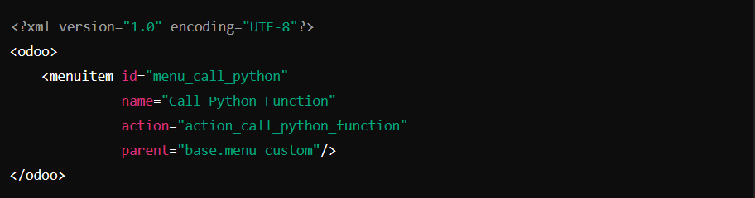

🔹 **Corrections:**

* Ensure that parent="base.menu_custom" is a valid parent menu ID. Replace it with the correct parent menu.
* The action field links to an action that will execute the Python function.

**Step 2: Create an Action**

Define an action that executes Python code when the menu item is clicked.

**File: your_module/views/action.xml**

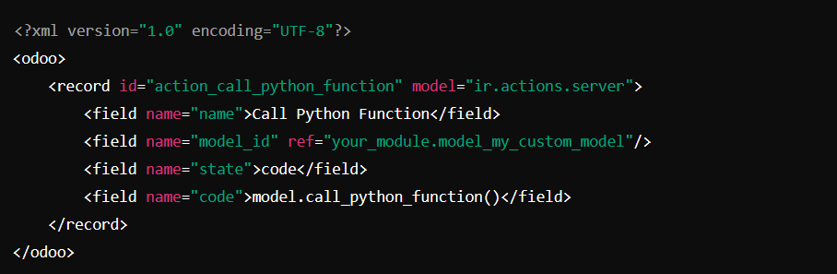

🔹 **Corrections:**

* The model_id should reference your_module.model_my_custom_model, ensuring it matches the model definition.
* Make sure the model_id exists in your database (ir.model) and is correctly referenced.

**Step 3: Define the Python Function**

Now, create the Python function inside your model.

**File: your_module/models/custom_model.py**

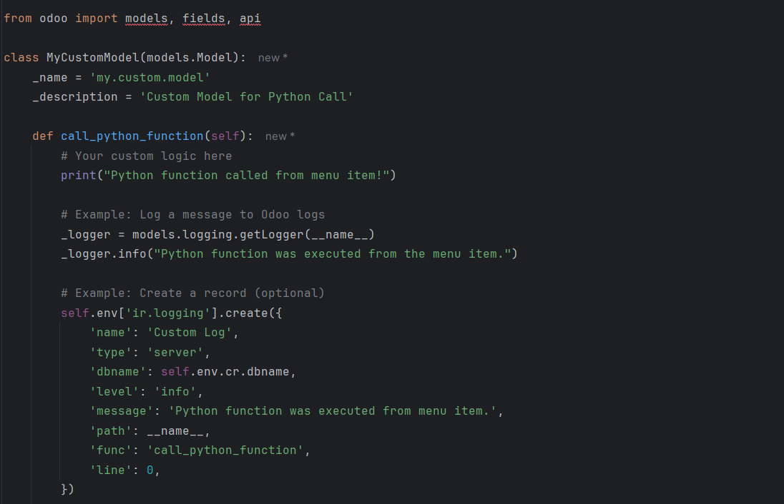🔹 **Corrections & Enhancements:**

* **Use Logging**: Instead of print(), use Odoo's logging (_logger.info(...)).
* **Error Handling**: If needed, wrap the function in a try-except block.
* **Record Creation**: The function logs an entry in ir.logging.

**Step 4: Load XML Files in Manifest**

Ensure your XML files are loaded in __manifest__.py.

**File: your_module/__manifest__.py**

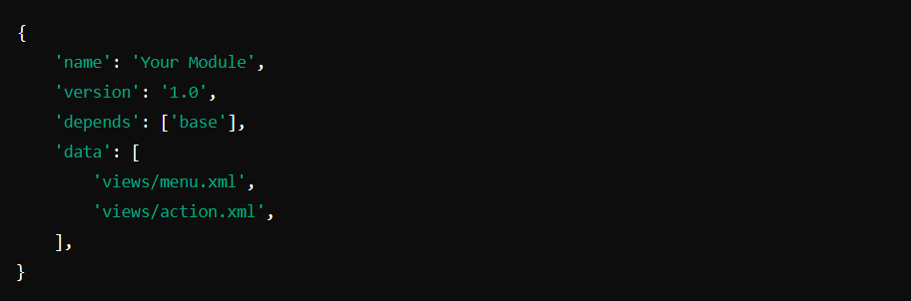🔹 **Corrections:**

* Add both menu.xml and action.xml in the data list.

✅ **Final Notes:**

* If the function is not being called, check ir.actions.server entries in the database (ir.actions.server model).
* If there’s a permissions issue, ensure the user has access rights to my.custom.model.